Mob No – 9957903698, 9435134860 Army Public School, Dinjan
2665 (Army) P.O : Dinjan, Via-Panitola
Dist : Dibrugarh (Assam)
Pin : 786189

395/ASD/Budget 20 Feb 2025

REQUEST FOR PROPOSAL (RFP) INVITATION OF
BIDS FOR SUPPLY OF 100 x MODERN BENCH CUM DESK
FOR CLASS ROOMS OF ARMY PUBLIC SCHOOL, DINJAN

REQUEST FOR PROPOSAL (RFP) NO 395/ASD/BUDGET DT 03 FEB 2025

- The Bids under (Two Bid System) are invited by Principal, Army Public School. Dinjan for works / supply of items listed in Part II of this RFP.

- The address and contact numbers for sending Bids or seeking clarification regarding this RFP are given below :

  - Bids /Queries to be addressed to : Principal
APS Dinjan
P.O : Dinjan, Via-Panitola
Dist : Dibrugarh (Assam)
Pin : 786189

  - Postal address for sending the Bids : Principal
APS Dinjan
P.O : Dinjan, Via-Panitola
Dist : Dibrugarh (Assam)
Pin : 786189

  - Name and designation of contact person : Staff Officer to Chairman

  - Mobile Number of the Contact Person : 9957903698, 9435134860
(9 AM to 4 PM all working days)
  - E-mail ID : apsdinjan@gmail.com

- The RFP is divided into five parts as follows :

          - Part - I Contains general information and instruction for the Bidders about the RFP such as the time, place of submission and opening of tenders, validity period of tenders etc.

          - Part –II Contains essential details of the items/service required, such as the schedule of requirement (SOR), Technical Specification, Delivery Period, Mode of Delivery and consignee details.

          - Part – III Contains standard conditions of RFP, which will form part of the contract with the successful Bidder.

          - Part – IV Contains special conditions applicable to this RFP and which will also form part of the contract with the successful Bidder.

          - Part – V Contains evaluation criteria and format for price bids.

            - This RFP is being issued with no financial commitment and the Buyer reserves the right to change or vary any part thereof at any stage, Buyer also reserves the right to withdraw the RFP, should it become necessary at any stage.

            - The vendor is required to sign on each page of the Bid.

            - The vendors are requested to forward receipts of the tender enquiry immediately.

Yours Faithfully

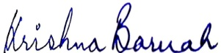

(Krishna Baruah)
Principal
Army Public School, Dinjan
Encls :- Part I to V only.

PART I- GENERAL INFORMATION

- Critical Dates. The critical dates with respect to the Tender ref No 395/ASD/Budget are as follows :-

Ser No | Item | Date
(a) | Published Date | 20 Feb 2025
(b) | Clarification start time and date | 21 Feb 2025
(c) | Clarification end time and date | 10 Mar 2025
(d) | Bid submission start date | 21 Feb 2025
(e) | Bid submission end date | 12 Mar 2025
(f) | Bid opening date | 13 Mar 2025

Manner of Depositing of Bids. Sealed Bids should be either dropped in the Tender Box marked as TENDER BOX for “TENDER FOR PURCHCASE OF 100 x MODERN BENCH CUM DESK FOR CLASS ROOMS OF ARMY PUBLIC SCHOOL, DINJAN” or sent by registered post at the address given above so as to reach by the due date and time. The Tender box will be kept in the office of Army Public, Dinjan-786189. Late tenders will not be considered. No responsibility will be taken for postal delay or non-delivery/non-receipt of Bid documents. Bids sent by E-mail will not be considered (unless specifically called for by these modes due to urgency).

- Time and date for opening of Bids. 13 Mar 2025 (1130 hrs) if due to any exigency, the due date for the Bids is declared a closed holiday, the Bids will be opened on the next working day at the same or any other day/time, as intimated by the Buyer.

- Location of the Tender Box. The Tender Box will be placed in Army Public School, Dinjan-786189. Only those Bids that are found in the Tender Box will be opened. Bids dropped in the wrong Tender Box will be rendered invalid.

- Place of Opening of the Bids. Army Public School, Dinjan – 786189 (The Bidders may depute their representative, duly authorized in writing, to attend the opening of Bids on the due date and time. Rates and important commercial/technical clauses quoted by all Bidders will be read out in the presence of the representatives of all the Bidders. This event will not be postponed due to non-presence of your representative.

- Single Bid Two Stage System. In case of the Single Bid two-stage system, only the Technical Bid would be opened on the time and date mentioned above. Opening of Commercial Bid will be carried out after acceptance of the Technical Bids, if the Technical Bids are found suitable after Technical evaluation is done by the Buyer

- Forwarding of Bids. The following documents should be placed in two separate covers during the bidding :-

Cover 1. Technical specification as per (Appx B of RFP) and documents forwarded by Bidders under their original memo/letter pad inter alia furnishing details like pictures and technical brochures/literatures of the products. TIN Number, GST Number, Bank address with NEFT account if applicable and complete postal and e-mail address or their office. Documents such as Registration documents of Firm, PAN Card, Power of Attorney if applicable and GST Registration Certificate.

Cover 2. Commercial bid as per format mentioned in Para 2 of Part V of RFP.

- Clarification Regarding Contents of RFP. A prospective Bidder who requires clarification regarding the contents of the bidding documents shall notify to the Buyers in writing about the clarification sought not later than 07 days prior to the date of issue of the Bids. Copies of the query and clarification by the Buyer will be sent to all prospective bidders who have received the bidding documents.

- Modification and withdrawal of Bids. A Bidder may modify or withdraw his bid after submission provided that the written notice of modification or withdrawal is received by the Buyer prior to deadline prescribed for submission of bids. A withdrawal notice may be sent by e-mail but it should be followed by a signed confirmation copy to be sent by post and such signed confirmation should reach the purchaser not later than the deadline for submission of bids. No bid shall be modified after the deadline for submission of bids and expiration of the period of bid validity specified. Withdrawal of a bid during this period will result in Bidder’s fortitude of bid security.

- Clarification Regarding Contents of the Bids. During evaluation and comparison of the bids, the Buyer may at its discretion ask the Bidder for clarification of his Bid. The request for clarification will be given in writing and no change in prices or substance of the bill will be sought, offered or permitted. No pot-bid clarification on the initiative of the bidder will be entertained.

- Rejection of Bids. Canvassing by the Bidder in any form, unsolicited letter and post tender correction may invoke summary rejection.

- Unwillingness of Quote. Bidders unwilling to quote should ensure that intimation to this effect reaches before the due date and time of opening of the Bid, failing which the defaulting Bidder may be de-listed for the given range of items as mentioned in this RFP.

- Validity of Bids. The Bids should remain valid upto 90 days from the last date of submission Bids.

PART II- ESSENTIAL DETAILS OF ITEMS/SERVICES REQUIRED
- Schedule of Requirement. List of items/services required is enclosed as Appendix A for commercial bid. The commercial bid will be submitted in as separate envelope.

Nomenclature | A/U | Qty
NILKAMAL Bench cum Desk | Units | 100

- Technical Details. Technical specifications of the equipment are enclosed as per Appendix B to the tender inquiry duly incorporating the required details given from (a) to (k) below as applicable and vetted by Competent Authority :-

        - Specifications/drawings as applicable.

        - Technical details with technical parameters.

        - Requirement of installation/commissioning.

        - Requirement of Factory Acceptance Trials (FAT), if applicable.

        - Requirement of Technical Documentation.

        - Nature of assistance required after completion of warranty.

        - Requirement of pre-site/equipment inspection.

- Brand/Make/Model offered.

- Copy of order secured from Govt agencies/ reputed organization in the recent past along with their technical bid will submitted.

      - Single Bid Two Stage System. In respect of Single bid two stage systems, bidders are required to furnish clause by compliance of specifications bringing out clearly the deviations from specification, if any. The Bidders are advised to submit the compliance statement in respect of the terms offered by them, as per the technical specification format given at Appendix B.

      - Delivery Period. Delivery period for supply of items within completion of 30 days from the effective date of contract. Please note that contract can be cancelled unilaterally by the Buyers in case items are not received within the contracted delivery period.

      - Terms for Delivery and Transportation. The stores will be delivered within 20 days after issue of supply order at Army Public School, Dinjan for the inspection and acceptance. No transportation cost will be paid to the vendor.

      - Consignee Details. Principal, Army Public School, P.O. - Dinjan – 786189, Dist – Dibrugarh (Assam).

PART III- STANDARD CONDITIONS OF RFP

The Bidder is required to give confirmation of their acceptance of the standard conditions of the tender enquiry mentioned below which will automatically be considered as part to the contract concluded with the successful Bidder (i.e. seller in the contract) as selected by the Buyer. Failure to do so may result in rejection of the Bid submitted by Bidder.

- Law. The supply order shall be considered and made in accordance with the laws of the Republic of India. The contract shall be governed by and interpreted in accordance with the laws of Republic India.

- Effective Date of the Contract. The contract shall come into effect on the date of issue of Supply Order and shall remain valid until the completion of the obligations of the parties under the contract.

- Arbitration. All disputes or differences arising out of or in connection with the contract shall be settled by bilateral discussion. Any dispute, disagreement or question arising out of or relation to the contract of relation to construction or performance, which cannot be settled amicably, may be resolved through arbitration. The standard clause of arbitration is as per Forms DPM-7, DPM-8 and DPM-9 (Available in MoD website and can be provided on request).

- Penalty for use of Undue Influence. The seller undertakes that he has not given, offered or promised to give directly or indirectly, any gift consideration, reward, commission, fees, brokerage or inducement to any person in service of the Buyer or otherwise in procuring the contracts or forbearing to do or for having done or forborne to do any act in relation to the obtaining or execution of the present contract or any other contract with Government of India for showing or forbearing to show favor or disfavor to any person in relation to the present contract or any other contract with the Government of India. Any breach of the aforesaid undertaking by the seller or any one employed by him or acting on his behalf (whether with or without the knowledge of the Seller) or the commission of any offers by the seller or anyone employed by him or acting on his behalf as defined in Chapter IX of the Indian Penal Code, 1869 or the Prevention of Corruption Act, 1986 or any other Act enacted for the prevention of corruption shall entitle the Buyer to cancel the contract and all or any other contracts with the Seller and recover from the Seller the amount of any loss arising from such cancellation. A decision of the Buyer or his nominee to the effect that a breach of the undertaking had been committed shall be final and binding on the Seller. Giving or offering of any gift, bribe or inducement or any attempt at any such act on behalf of the Seller towards any officer/ employee of the Buyer or to any other person in a position to influence any officer/employee of the Buyer for showing any favor in relation to this or any other contract, shall render the Seller to such liability/penalty as the Buyer may deem proper, including but not limited to termination of the contact, imposition of penal damages, forfeiture of the Bank Guarantee and refund of the amounts paid by the Buyer.

- Agents/ Agency Commission. The seller shall declare to the Buyer that the seller is the original manufacturer/authorized dealer of the stores referred to in this contract and has not engaged any individual or firm, whether Indian or foreign whatsoever, to intercede, facilitate or in any way to recommend to the Government of India or any of its functionaries, whether officially or unofficially, to the award of the contract to the seller, nor has any amount been paid promised or intended to be paid to any such individual or firm in respect of any such intercession, facilitation or recommendation. The seller agrees that if it established at any time to the satisfaction of the Buyer that the present declaration is in any way incorrect or if at a later stage it is discovered by the Buyer that the seller has engaged any such individual/ firm and paid or intended to pay any amount, gifts, reward, fees, commission or consideration to such person, party, firm, institution, whether before or after the signing of this contract, the Seller will be liable to refund that amount to the Buyer. The Seller will also be debarred from entering into any supply contract with the Government of India for a minimum period of five years. The Buyer will also have a right to consider cancellation of the contract either wholly or in part without any entitlement or compensation to the seller who shall in such an event will be liable to refund all payments made by the Buyer in terms of the contract along with interest at the rate of 2% per annum above LIBOR rate. The Buyer will also have the right to recover any such amount from any contract concluded earlier with the Government of India.

- Access to Books of Accounts. In case it is found to the satisfaction of the Buyer that the seller has engaged an Agent or paid commission or influenced any person to obtain the contract as described in clauses relating to Agents/Agency Commission and penalty for use of undue influence, the Seller on a specific request of the Buyer, shall provide necessary information/ inspection of the relevant financial documents/ information.

- Non-Disclosure of Contract Documents. Except with the written consent of the Buyer/Seller, other party shall not disclose the contract or any provision, specification, plan, design, pattern sample or information thereof to any third party.

- Liquidated Damages. In the event of the Seller’s failure to submit the Bonds, Guarantees and Documents, supply of stores/ goods and conduct trials, installation of equipment, training etc as specified in this contract, the Buyer may, at his discretion, withhold any payment until the completion of the contract. The BUYER may also deduct from SELLER as agreed liquidated damages (LD) to the sum of 0.5% of the contract price of the delayed/undelivered stores/services mentioned above for every week of delay or part of a week, subject to the maximum value of the Liquidated Damages being not higher than 07% of the value delayed stores.

- Termination of Contract. The Buyer shall have the right to terminate this Contract in part of in full an any of the following cases :-

        - The delivery of the material is delayed for causes not attributable to Force Majeure for more than one (30 days) month of after the scheduled date of delivery.

        - The Seller is declared bankrupt or becomes insolvent.

        - The delivery of the Material is delayed due to causes of Force Majeure for more than two months after the scheduled date of delivery.

        - The Buyer has noticed that the Seller has utilized the service of any Indian/Foreign agent in getting this contract and paid any commission to such individual/company etc.

        - As per decision of the Arbitration Tribunal.

- Notices. Any notice or permission in the contract shall be written in the English language and may be delivered personally or may sent by e-mail or registered pre-paid mail/ airmail, addressed to the last known address of the party to whom it is sent.

- Transfer and Sub-letting. The Seller has no right to give, bargain, sell, assign or sublet or otherwise dispose of the Contract or any part thereof, as well as to give or to let a third party take benefit or advantage of the present Contract or any part thereof.

- Patents and other Industrial Property Rights. The process stated in the present Contract shall be deemed to include all amount payable for the use patents, copyright, registered charges, trademarks and payments for any other industrial property rights. The Seller shall indemnify the Buyer against tall claim from a third party at any time on account of the infringement of any or all the rights mentioned in a previous paragraphs, whether such claims arise in respect of manufacture or use. The Seller shall be responsible for the completion of the supplies including spares, tools, technical literature and training aggregates irrespective of the fact of infringement of the supplies, irrespective of the fact of infringement of any or all the right mentioned above.

- Amendments. No provision of present Contract shall be changed or modified in any way (including this provision) either in whole or in part except by an instrument in writing made after the date of this Contract and signed on behalf of the parties and which expressly states to amend the present Contract.

- GST. The Seller must be in possession of GSTIN number and trade license for the said purpose.

PART IV- SPECIAL CONDITIONS OF RFP

The Bidder is required to give confirmation of their acceptance of special conditions of the request for proposal mentioned below which will automatically be considered as part of the Contract concluded with successful Bidder (i.e. Seller in the Contract) as selected by the Buyer, Failure to do so may result in rejection of Bid submitted by Bidder.

- Guarantee by way of Bank Guarantee Through a Public Sector Bank or a Private Sector bank authorized to conduct government business (ICICI Bank Ltd, Axis Bank Ltd or HDFC Bank Ltd.) for a sum equal to 10% of the contract value within 30 days of receipt of the confirmed ordered. Performance Bank Guarantee should be valid up to 60 days beyond the date of warranty . The specimen of PBG is given in Form DPM-15 (available on MoD website and can be provide on request).

- Payment Terms for Sellers. 100% payment on delivery and acceptance by the user. It will be mandatory for the Bidders to indicate their bank account numbers and other relevant e-payment details so that payment could be made through ECS/EFT mechanism instead of payment through cheques, wherever feasible. The payment of bill will be made on submission of the following documents by the Seller to the Paying Authority along with the bill :-

        - Ink-signed copy of contingent bill/Seller’s Bill.

        - Ink-signed copy of Commercial invoice/Seller’s Bill.

        - Copy of Supply Order where required under delegation of powers.

        - CRVs in duplicate.

        - Inspection note.

        - Claim for statutory and other levies to be supported with documents/ proof of payment such as Excise duty challan, customs duty clearance certificate, Octroi Receipt, proof of payment for EPE/ESIC contribution with nominal roll of beneficiaries , etc as applicable.

        - Exemption certificate for GST, if applicable.

        - Guarantee/Warranty Certificate.

- Performance Bank guarantee/Indemnity Bond where applicable.

- DP extension letter with CFA’s sanction, where required under delegation of powers, indicating whether extension is with or without LD.

- Details for electronic payment vis. Account holder’s name, Bank name, Branch name and address, Account type, Account number, IFSC Code, MICR Code, (if these details are not incorporated in supply order/Contract).

- Any other document/ certificate that may be provided for in the supply order/ contract.

- User Acceptance.

- Xerox copy of PBG.

Note :- If payment through letter of credit or stage-wise payment is desired, the bidder must specify the same in the bid. Acceptance of the name will be subject to negotiations during PNC within the provision of DPM 2009 as amended.

- Advance Payment. No advance payment(s) will be made.

- Payment Authority.

(a) Indigenous Sellers: The payment of bills will be made on submission of the following documents by the seller to the ARMY PUBLIC SCHOOL, DINJAN through the buyer along with the bill:-
(i) Inspection note
(ii) Guarantee/warranty certificate of the product
(iii) Details of electronic payment viz. Account holder’s name, bank name, branch name and address. Account type, Account number, IFSC Code, MICR Code (if these details are not incorporated in the supply order)
(iv) Any other documents/certificate that may be provided for in the Supply Order
(v) User acceptance certificate.

- Risk and Expense Clause :-
  - Should the stores or any installment thereof not be delivered within the time or times specified in the contract documents, or if defective delivery is made in respect of the stores or any installment thereof, the Buyer shall after granting the Seller 45 days to cure the breach, be at liberty, without prejudice to the right to recover liquidated damages as a remedy for breach of contract to declare the contract as cancelled either wholly or to the extent of such default.

  - Should the stores or any installment thereof not perform in accordance with the specifications/parameters provided by the SELLER during the check proof tests to be done in the BUYER’s country/ location, the BUYER shall be at liberty, without prejudice to any other remedies for breach of contract, to cancel the contract wholly or to the extent of such default.

  - In case of a material breach that was not remedied within 45 days, the BUYER shall, having given the right of first refusal to the SELLER be at liberty to purchase, manufacture, or procure from any other source as he thinks fit, other stores of the same or similar description to make good :-

                - Such default.

                - In the event of the contract being wholly determined the balance of the stores remaining to be delivered there under.

- Any excess of purchase price, cost of manufacturer, or value of any stores procured from any other supplier as the case may be, over the contract price appropriate to such default or balance shall be recoverable from the Seller. Such recoveries shall not exceed 10% of the value of the contract.

- Force Majeure. Should any Force Majeure circumstances arise, each of the contracting party shall be excused for the non-fulfillment or for the delayed fulfillment of any of its contractual obligations, if the affected party within 10 days of its occurrence informs the other party in writing. Force Majeure shall mean fires, floods, natural disasters or other acts, that are unanticipated or unforeseeable and not brought about at the instance of the party claiming to be affected by such event, or which, if anticipated or foreseeable , could not be avoided or provided for, and which has caused the non-performance or delay in performance, such as war, turmoil, strikes, sabotage, explosions, quarantine restriction beyond the control or either party. A Party claiming Force Majeure shall exercise reasonable diligence to seek to overcome the Force Majeure event and to mitigate the effects thereof on the performance of its obligations under this contract.

- Earliest Year of Manufacture. The Seller confirms that the stores to be supplied under this Contract shall be new i.e. not manufactured before May 2020 Certificate to this effect will need to be enclosed with the bill.

- Specification. The Seller guarantees to meet the specification as per Part II of this Tender Enquiry.

- OEM Certificate. In case of the Seller is not the OEM, the agreement certificate with OEM for sourcing the spares shall be mandatory. However, where OEMs do not exist, minor aggregates and spares can be sourced from authorized vendors subject to quality certification.

- Packing and Marking. The Seller shall provide packing and preservation of the equipment and spares /goods contracted so as to ensure their safety against damage in the conditions of land, sea and air transportation, transshipment, storage and weather hazards during transportation, subject to proper cargo handling. The Seller shall ensure that the stores are packed in containers, which are made sufficiently strong and with seasoned wood. The packing cases should have hooks for lifting by crane/fork lift truck. Tags with proper marking shall fastened to special equipment, which cannot be packed.

- Inspecting Authority. The inspection will be carried out by Consignee Acceptance Testing Board. The mode of Inspection will be User Inspection/ Acceptance testing procedure. The seller would be required to provide all test facilities at Buyer’s premise at Seller’s own cost for acceptance and inspection by Buyer.

- Franking Clause. The following Franking clause will form part of the contract placed on successful Bidder :-

  - In the case of Acceptance of Goods. “The fact that the goods have been inspected after the delivery period and passed by the Inspecting Officer will not have the effect of keeping the contract alive. The goods are being passed without prejudice to the rights of the Buyer under the terms and conditions of the contract”.

  - In the case of Rejection of Goods. “The fact that the goods have been inspected after the delivery period and rejected by the Inspecting Officer will not bind the Buyer in any manner. The goods are being rejected without prejudice to the rights of the Buyer under the terms and conditions of the contract”.

- Claims. The following claims clause will form part of the contract placed on successful Bidder :-

  - The claims may be presented either (a) on quantity of the stores, where the quantity does not correspond to the quantity shown in the Packing List/Insufficient in packing or (b) on quality of the stores, where quality does not correspond to the quality mentioned in the contract.

  - The quantity claims for deficiency of quantity shall be presented within 45 days of completion of JRI and acceptance of goods. The quantity claim shall be submitted to the Seller as per Form DPM-22 (Available in MoD website and can be given on request).

  - The quality claims for defects or deficiencies in quality noticed during the JRI shall be presented within 45 days of completion of JRI and acceptance of goods. Quality claims shall be presented for

defects or deficiencies in quality noticed during warranty period earliest but not later than 45 days after expiry of guarantee period. The quality claims shall be submitted to the “Seller as per Form DPM-23 (Available in MoD website and can be given on request).

  - The description and quantity of the stores are to be furnished to the Seller along with concrete reasons for making the claims. Copies of all the justifying documents shall be enclosed to the ented claim. The Seller will settle the claims within 45 days from the date of the receipt of the claim at the

Seller’s office, subject to acceptance of the claim by the Seller. In case no response is received during this period, the claim will be deemed to have been accepted.

  - The Seller shall collect the defective or rejected goods from the location nominated by the Buyer and deliver the repaired or replaced goods at the same location under Seller’s arrangement.

  - Claims may also be settled by reduction of cost of goods under claim from bonds submitted by the Seller or payment of claim amount by Seller through demand draft drawn on an Indian Bank, in favor of Principal Controller / Controller of Defence Accounts concerned.

  - The quality claims will be raised solely by the Buyer and without any certification/countersignature by the Seller’s representative stationed in India.

- Warranty. The following Warranty will form part of the contract placed on the successful Bidder :-

  - Except as otherwise provided in the invitation tender, the Seller hereby declares that the goods stores articles sold/supplied to the Buyer under this contract shall be of the best quality and workmanship and new in all respects and shall be strictly in accordance with the specification and particulars contained / mentioned in contract.

  - The items supplied the contract shall be under warranty against defective design, material, workmanship, performance for a period of 12 months from the date of successful installation. During warranty period, any malfunctioning of the product or replacement of defective items shall be repaired/replaced by the vendor free of cost at consignee’s site as early as possible and not later than seven days.

  - The Seller warrants that the goods supplied under the contract conform to technical specifications prescribed and shall perform according to the said technical specifications.

  - The Seller shall associate technical personnel of the Maintenance agency and Quality Assurance Agency during warranty repair and shall also provide the details of complete defects, reasons and remedial actions of defects. Guarantee that they will supply spare parts, if and when required on agreed basis for an agreed price. The agreed basis could be and including but without any limitation an agreed discount on the published catalogue or an agreed percentage of profit on the landed cost.

  - If a particular equipment/goods falls frequently and/or the cumulative down time exceeds 1 month (30 days) of the warranty period, the complete equipment shall be replaced free of cost by the Seller within a stipulated period of two weeks of receipt of the notification from the Buyer. Warranty of

12 months of the replaced equipment would start from the date of acceptance after Joint Receipt Inspection by the Buyer/date of installation and commissioning at the consignee’s site.

  - In case of the complete delivery of any Support Package of the items is delayed beyond the period stipulated in this contract, the Seller undertakes that the warranty period for the goods / stores shall be extended to that extent, provided the cumulative down time is not more than 30 days after which the seller shall be required to replace the complete equipment free of cost.

  - The items will be installed and will be handed over in serviceable condition for user inspection and acceptance within the delivery period.

PART V- EVALUATION CRITERIA & PRICE BID ISSUE
      - Evaluation Criteria. The broad guidelines for evaluation of Bids will be as follows :-

- Only those Bids will be evaluated which are found to be fulfilling all the eligibility and qualifying requirements of the RFP both technically and commercially.

- In respect of Single Bid two stage system, the technical Bids forwarded by the Bidders will be evaluated by the Buyer with reference to the technical characteristics of the equipment as mentioned in the RFP. The compliance of the technical bids would be determined on the basis of the parameters specified in the RFP. The Price Bids of only those Bidders will be opened whose Technical Bids would clear the technical evaluation.

- The lowest bid will be decided upon the lowest quoted by the particular Bidder excluding taxes and/or duties as per the Price Format given at Para 2 below. The consideration of taxes and duties in evaluation process will be as follows : -

    - In cases where only indigenous Bidders are competing, all taxes and duties (including those for which exemption certificates are issued) quoted by the Bidders will be excluded. The ultimate basic cost to the Buyer would be the deciding factor for ranking of Bids.

    - In cases where both foreign and indigenous Bidders are competing, following criteria would be followed :-

(aa) In case foreign Bidders, the basic cost (CIF quoted by them would be the basis for the purpose of comparison of various tenders.

(ab) In case of indigenous Bidders, GST on fully formed equipment would be off loaded.

- In import cases, all the foreign quotes will be brought to a common denomination in Indian Rupees by adopting the exchange rate as BC Selling rate of the State Bank of India on the date of the opening of Price Bids.

- If there is a discrepancy between the unit price and the total price that is obtained by multiplying the unit price and quantity, the unit price will prevail and the total price will be corrected. If there is a discrepancy between words and figures, the amount in words will prevail for calculation of price.

- The Lowest Acceptable Bid will be considered further for placement of contract/Supply Order after complete clarification and price negotiations as decided by the Buyer. The Buyer will have the right to award contracts to different Bidders for being lowest in particular items. The Buyer also reserves the right to do Apportionment of Quantity, if it is convinced that Lowest Bidder is not in a position to supply full quantity in stipulated time.

- Any other criteria as applicable to suit a particular case.

- Price Bid Format. The Price Bid Format is given below and Bidders are required to fill this up correctly with full details and submit it with their commercial bids received without or incomplete “Price Bid” format will be rejected :-
Appendix – A
(Refers to Para 1 of Part II of RFP No 395/ASD/Budget)
PART II (Financial Bid)

Ref. No :NIT- 395/ASD/Budget

1. Name of Bidder :

Desk cum Bench for Students of Army Public School Dinjan :

S No | Description | Rate of the items (Rs.)
Desk cum Bench (Single Seater 02 Chairs)
(As per given specification)
 | GST(if applicable)
TOTAL AMOUNT
(In words: )

Note:

a. If there is a discrepancy between the rates quoted in words and in figures, the amount quoted in words shall prevail.

b. The Financial Bid shall be considered as a single job.

Signature

Name and Address of the Bidder with stamp

Place:

Date:

SPECIFICATIONS :

S S.No | Description
1 | The specification is as under  (a) Desk - 01  (i) Length - 110 cm  (ii) Breadth - 40 cm  (iii) Height - 76 cm  (iv) Book Shelve - 11 cm  (b) Bench Chair Single Sitter) - 02  (i) Length - 38 cm  (ii) Width - 36 cm  (iii) Height from surface - 45 cm  (c) Frame  (i) GI Rectangle Pipe - 2 inches
1 | PRODUCT IMAGES
1 | Desk | Chairs | Complete Set
1 | 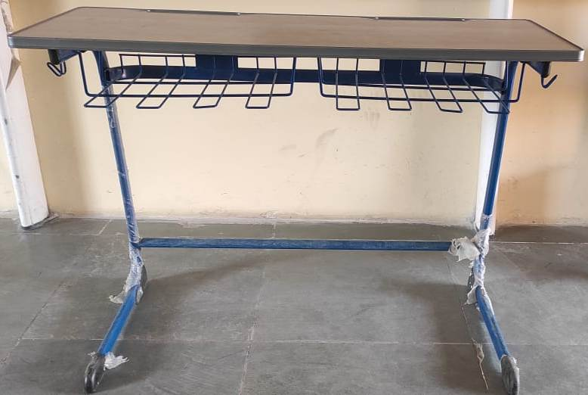 | 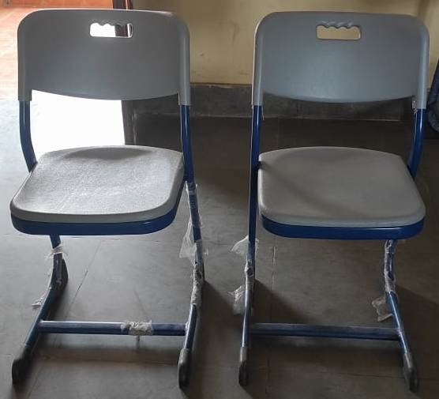 | 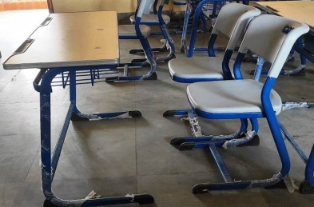  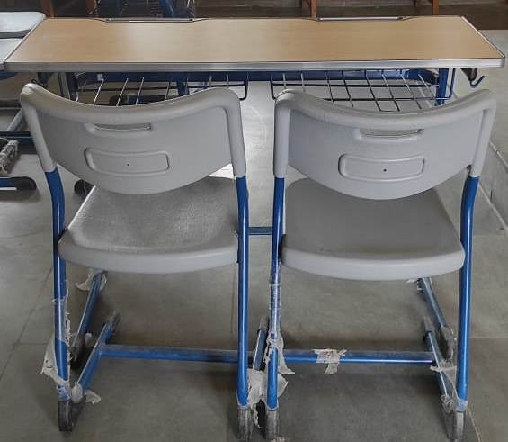

Appendix – B
(Refers to Para 3 of Part II of RFP No 395/ASD/Budget)

TECHNICAL SPECIFICATION OF PROCUREMENT 100 x MODERN BENCH CUM DESK (NILKAMAL)

PART- I (TECH BID)

All the commercial conditions shall be indicated in this part. Deviations, if any, to our specifications shall be brought out very clearly. Bidders shall mentioned point-wise confirmation with regard to technical specifications given in our enquiry.
Ser No | Particulars | Details
 | Bidders Name
 | Registered Office and address
 | Working place of the office
 | Year of establishment
 | Type firm (Ownership, Partnership, Pvt Ltd or Ltd Co).
 | Details of ownership (Name and address of the board of director, partners etc)
 | Name of the authorized signatory who is authorized to sign all the relevant documents (Power of attorney, if any to be submitted).
 | Contact details
 | Name of the contact person
 | Designation
 | Telephone Number (Office)
 | Mobile No
 | Email ID
 | Address for communication
 | GST No
 | Pan No
 | Whether agency has been blacklisted by any Govt or Semi-Govt. Organization or any other organization? If Yes, provide details | YES/NO
 | Do agree to provide services as per the institute’s requirement? | YES/NO
 | No. of years of service in the field of supply & installation of furniture. | YES/NO
 | Bank Particulars
 | Account Name
 | Type of A/C:(SB/CA/CC)
 | A/C No.
 | IFC Code
 | Name of the Bank
 | Branch

Enclose all certificate in support of above statements.

Date: Authorized Signatory
Name:
Place: Disignation:
Company:
Contact No:

Company Seal

Note : All documents as per Para 7 of Part I of this RFP are also required to be submitted along with this Appendix.

